Solution Architecture
Field | Details
Date | 01 October 2026
Team ID | SWTID-2026-3718
Project Name | ComicCraft - AI Comic Story Creator
Maximum Marks | 5 Marks

Figure: ComicCraft System Architecture

Solution Architecture Diagram
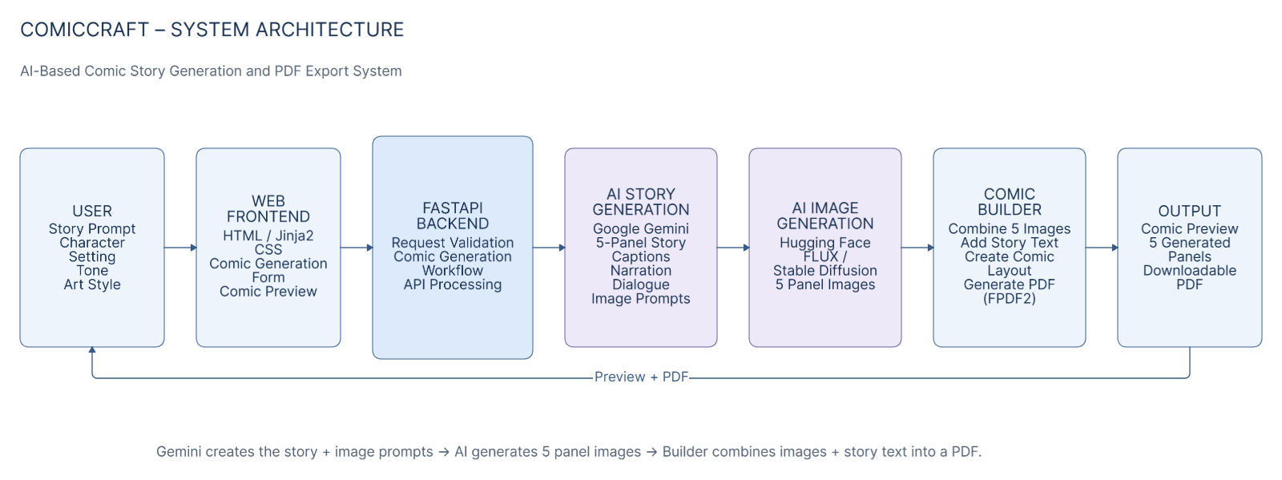
Layer | Component | Technology | Project File / Storage
Presentation / Client | Browser UI | HTML + Jinja2 + CSS | templates/, static/css/
Application / API | FastAPI + Uvicorn | Python | app/main.py, app/routes.py
AI Text | Outline + Story | google-genai / Gemini | gemini_flash.py, gemini_pro.py, llm_utils.py
AI Image | Panel artwork | Diffusers / Hugging Face / FLUX / Stable Diffusion | image_generator.py
Orchestration | End-to-end workflow | Python | workflow.py
Media / Layout | Panel binding + image embedding | Pillow + base64 | layout_builder.py, media.py
Data / File | JPEG panels + PDF exports | Local filesystem | static/panels, static/exports

High-Level Flow
Flow | From | To | Data
1 | Browser | FastAPI | Story prompt + character + setting + tone + art style
2 | FastAPI workflow | Gemini outline | Validated creative input
3 | Gemini outline | Gemini story | Five-panel outline
4 | Story service | Image generation | Panel image prompts
5 | Image generation | File storage | Verified JPEG panels
6 | Workflow | Preview | Panel text + image paths/data URIs
7 | Workflow | FPDF2 | Panel layout
8 | FPDF2 | File storage | Five-page A4 PDF

Component Description Table
Component | Role | Technology
Presentation Layer | Collects input and renders preview/export UI. | HTML, Jinja2, CSS
API Layer | Validates requests and exposes routes. | FastAPI, Uvicorn, Pydantic
AI Text Layer | Creates outline and expanded story. | google-genai, Gemini
Image Layer | Generates/verifies/saves images and applies fallbacks. | Pillow, Diffusers, Hugging Face
File Layer | Stores generated panels and PDFs. | Local filesystem

